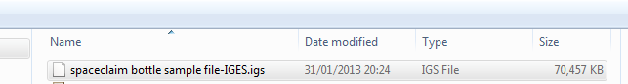Step 1 – open .igs file

Step 2 - create a plane through 3 pts at the bottom of the bottle

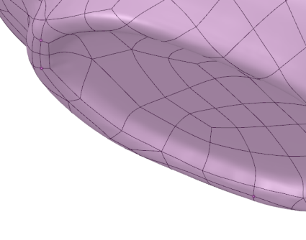

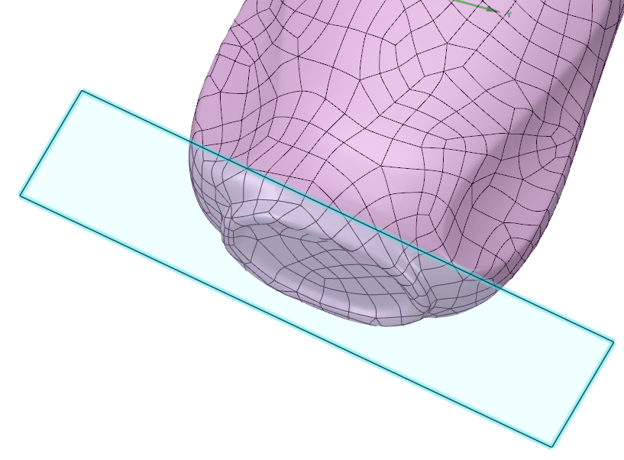

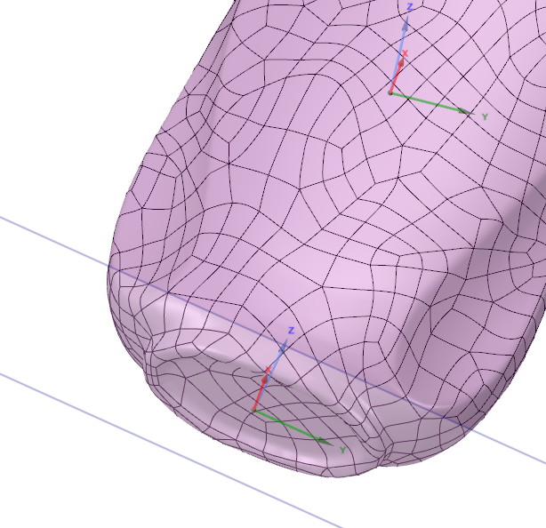Step 3 – insert a new origin on the plane and re-orient the z –axis of this origin to go up through the bottle.

Step 4 – move re-align the world co-ordinate system (x0y0z0) to be on this new origin

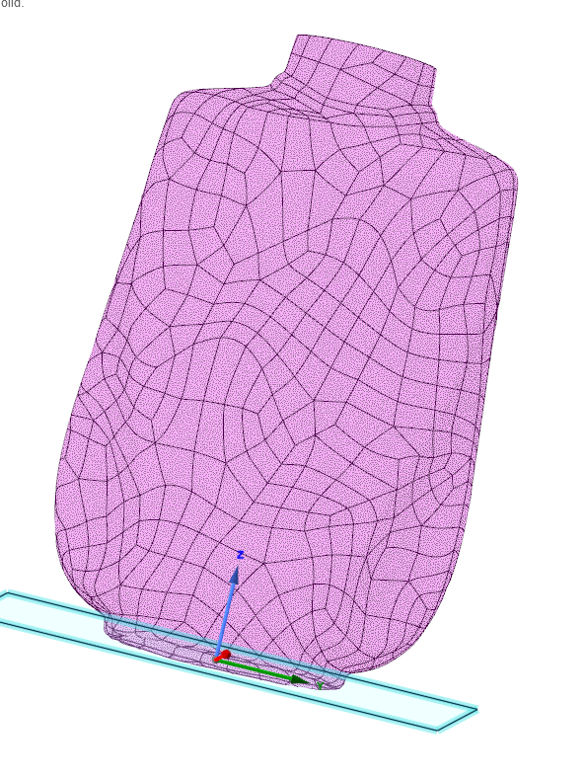

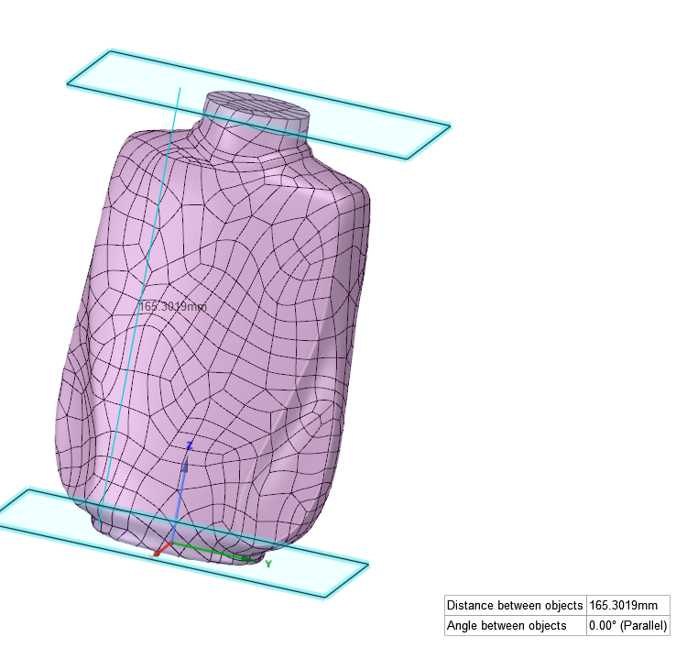Step 5 – move – copy the plane to the top of the bottle.

Step 1 to 5 we envisage being the “manual process” required to set up each of the 300 bottles to then have the “macro” run on them. The macro needs to:-

Step 6 – Generate a 1000 planes equally spaced along the height of the bottle

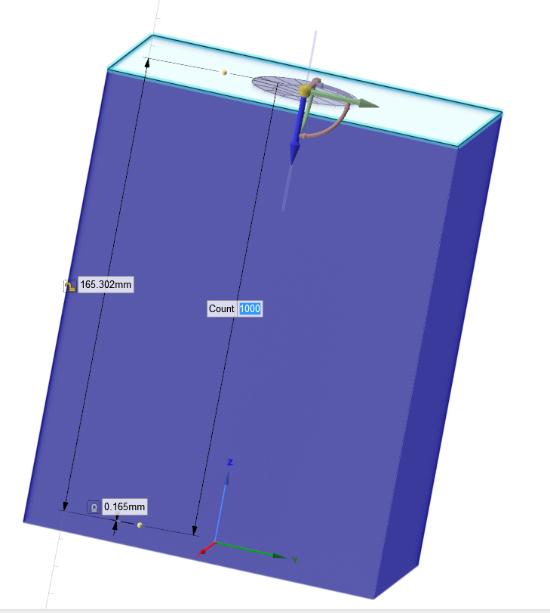

Step 7 – for each plane section the bottle solid and calculate the volume below the plane and record this value in spreadsheet in the following format e.g. for the above example

Bottle filename: Overall Height: 165.302

Section No Height Volume to Height

1 0.165 31.893 mm^3  
2 0.330 106.7341 mm^3

Etc……